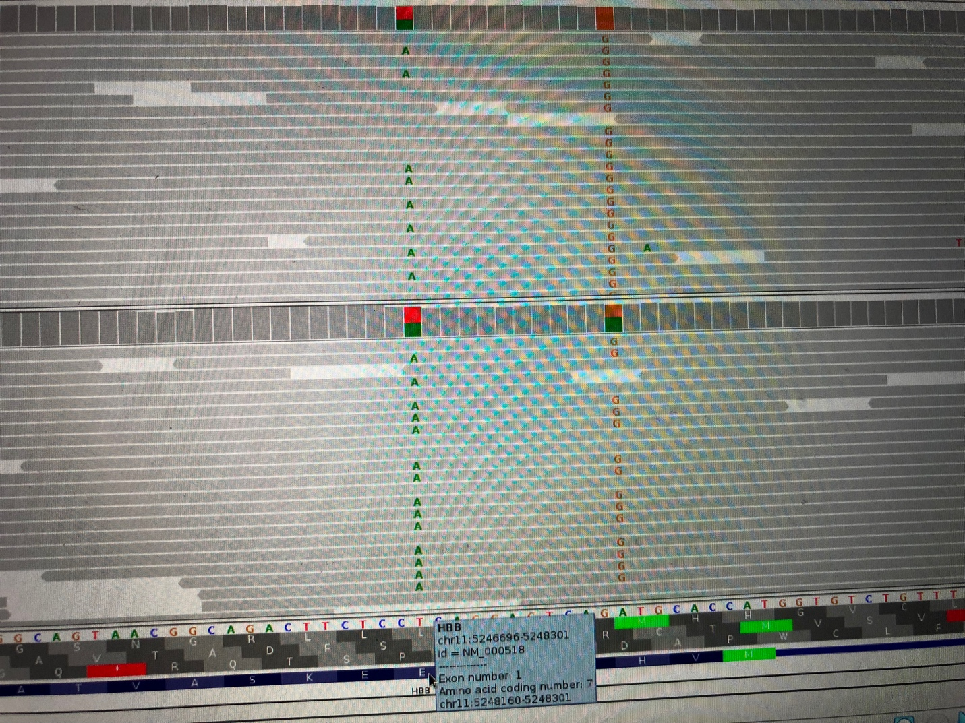

**As the picture shows, the id =NM_000518 has the variant at E7.**

By Expanding the dbSNP track,

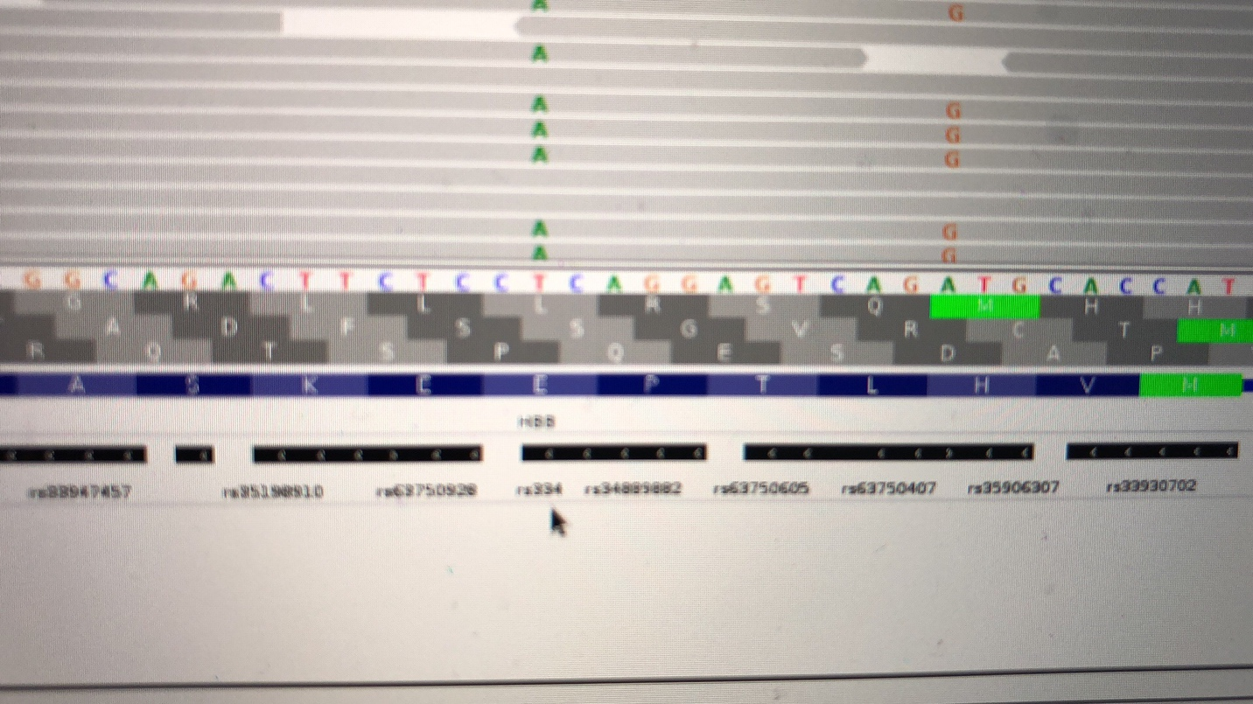

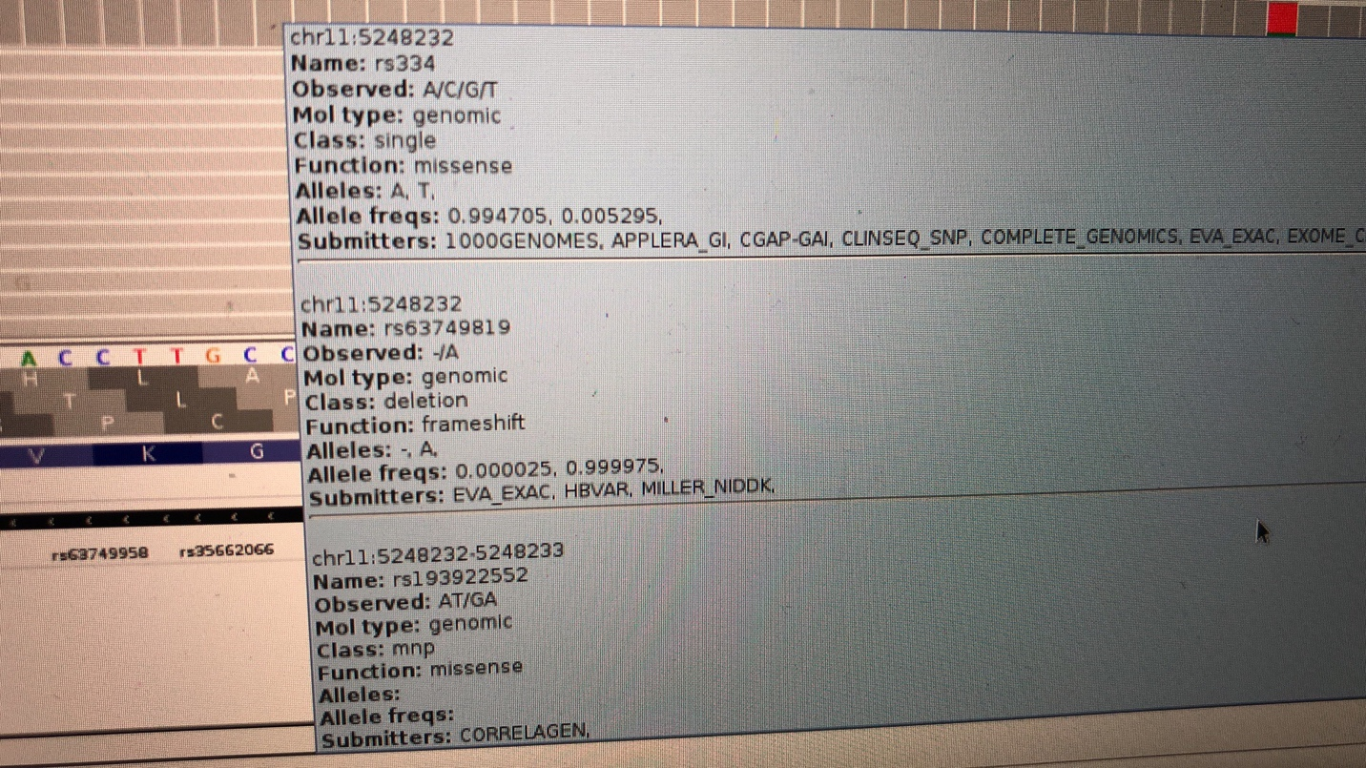

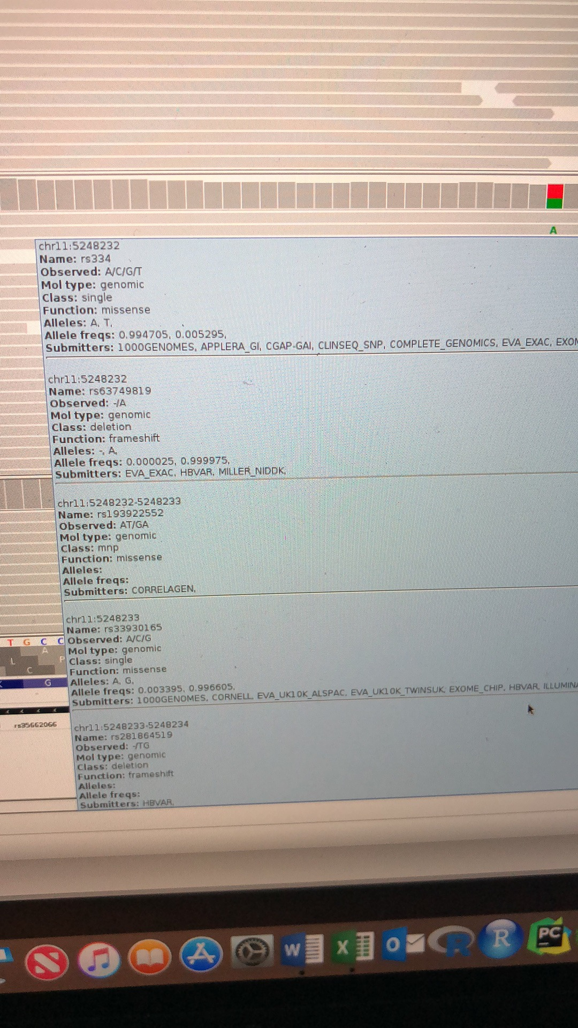

**rs334, rs63749819, rs193922552, rs33930165, and rs281864519 are associated with this variant at the E7 position.**